Vale: Laurence ‘Khantipalo” Mills
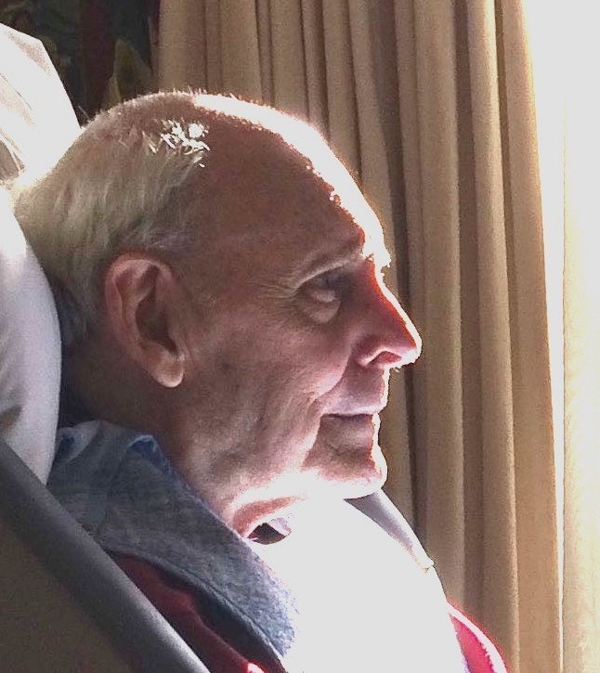
It is with great sadness that we announce the passing of Laurence Mills, the former Phra Khantipalo. He was a well known teacher in the Theravadan tradition and was also well known to Tibetan Buddhist practitioners. He is considered one of the seminal figures of Buddhist teaching in Australia. He died on Monday 5 July after many years of ill health, during which time a number of his former students supported him with much care and compassion.
Laurence was born in 1932 in London, studied horticulture; then while called up for service in the British army read books on Buddhism and shortly after, in 1961, he ordained as a Buddhist monk. After 15 years in Asia, studying and practising in forest monasteries, he came to Australia in 1973, having been invited to help establish Wat Buddharangsee in Sydney.
In 1978, along with Ayya Khema he founded Wat Buddha Dhamma, a forest retreat outside of Sydney, teaching and conducting many retreats there. He encouraged women to ordain; as early as 1984 he ordained three nuns. He designed and built the beautiful Meditation Sala at this Wat, which was miraculously saved from the Summer 2019-20 bushfires.
Through the 1970s and 80s, he travelled widely throughout Australia giving public talks and conducting retreats. He was a renowned Pali scholar and author of many books, such as ‘Buddhism Explained,’ ‘What is Buddhism?’ ‘Calm and Insight’ and ‘Buddha- My Refuge’
In 1992 he disrobed and pursued an interest in the Dzogchen school of Tibetan Buddhism. He married and co-founded the Bodhi Citta Buddhist Centre, in Far North Queensland, before ill health caused him to retire from active teaching. Late in life Laurence briefly became a novice again at Quang Minh temple. However following a further decline in his health, he entered residential aged care where he remained until the end of his life.

A memorial service will be held at Quang Minh Temple, 18 Burke Street, Braybrook, Victoria 3019
On Monday 12 July 2021
Sangha dana 11.00am
Ceremony 12.45pm
Laurence indicated his preference that attendees NOT dress in sombre- hued clothing at funerals
Please check the Laurence Mills Facebook page for livestream details closer to the day.

